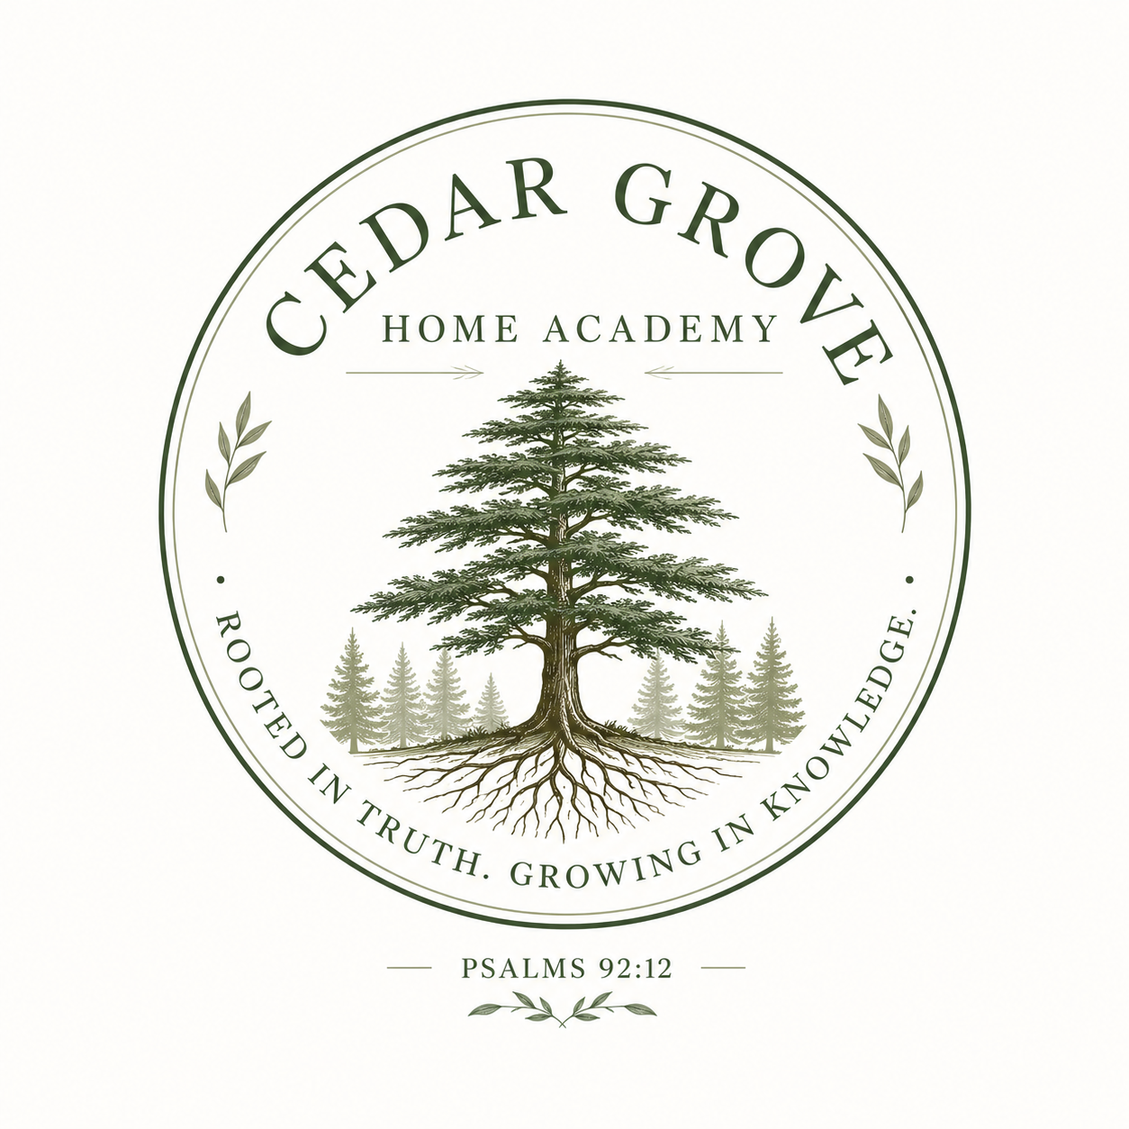
CEDAR GROVE
H O M E A C A D E M Y
HOMESCHOOL RECORDS & HIGH SCHOOL PLANNING BINDER

Student Name: _____________________________________________
Graduation Class: _____________________________________________
ROOTED IN TRUTH. GROWING IN KNOWLEDGE.
PSALMS 92:12

CEDAR GROVE
H O M E A C A D E M Y
SCHOOL PROFILE & EDUCATIONAL PHILOSOPHY
School Name: _____________________________________________
School Address: _____________________________________________
Administrator/Parent Educator: ___________________________________
Primary Contact Information: ___________________________________

Mission Statement
_________________________________________________________________________________________________________
_________________________________________________________________________________________________________

Educational Philosophy
_________________________________________________________________________________________________________
_________________________________________________________________________________________________________

School Information
Academic Year | School Year Dates | Instructional Model
ROOTED IN TRUTH. GROWING IN KNOWLEDGE.
PSALMS 92:12

CEDAR GROVE
H O M E A C A D E M Y
STUDENT PERMANENT RECORD
Student's Full Legal Name: ________________________________________
Date of Birth: ________________________________________
Parent/Guardian: ________________________________________
Home Address: ________________________________________
Date Enrolled at Cedar Grove Home Academy: ________________________________________
Expected Graduation Date: ________________________________________
Previous School(s) / Program(s): ________________________________________

Prior Academic Records Received
School / Provider | Years Attended | Records on File
ROOTED IN TRUTH. GROWING IN KNOWLEDGE.
PSALMS 92:12

CEDAR GROVE
H O M E A C A D E M Y
CERTIFICATE OF ENROLLMENT

This certifies that
Student Name: _____________________________________________
Grade Level: _____________________________________________
Academic Year: _____________________________________________
is officially enrolled as a student of Cedar Grove Home Academy and is participating in a home-based educational program.

Parent/Administrator Signature | Date
ROOTED IN TRUTH. GROWING IN KNOWLEDGE.
PSALMS 92:12

CEDAR GROVE
H O M E A C A D E M Y
FOUR-YEAR HIGH SCHOOL PLAN
Student Name: _____________________________________________
Expected Graduation Year: ________________________________________
Subject Area | Grade 9 | Grade 10 | Grade 11 | Grade 12
Planning Notes:
_________________________________________________________________________________________________________
_________________________________________________________________________________________________________
ROOTED IN TRUTH. GROWING IN KNOWLEDGE.
PSALMS 92:12

CEDAR GROVE
H O M E A C A D E M Y
GRADUATION CREDIT TRACKER
Subject Area | Credits Required | Credits Earned | In Progress | Remaining

Total Required | Total Earned | Total In Progress | Total Remaining
ROOTED IN TRUTH. GROWING IN KNOWLEDGE.
PSALMS 92:12

CEDAR GROVE
H O M E A C A D E M Y
ANNUAL GRADE & COURSEWORK RECORD
Student Name: _____________________________________________
Grade Level: _____________________________________________
School Year: _____________________________________________
# | Subject / Course | School or Provider | Final Grade | Credit Earned
Parent/Teacher/Administrator Signature | Date
ROOTED IN TRUTH. GROWING IN KNOWLEDGE.
PSALMS 92:12

CEDAR GROVE
H O M E A C A D E M Y
OFFICIAL TRANSCRIPT TEMPLATE
Student Name: _____________________________________________
Date of Birth: _____________________________________________
Expected / Actual Graduation Date: ___________________________________

Grade 9
Course Title | Provider | Final Grade | Credit

Grade 10
Course Title | Provider | Final Grade | Credit

Grade 11
Course Title | Provider | Final Grade | Credit

Grade 12
Course Title | Provider | Final Grade | Credit
Cumulative Credits | Cumulative GPA | Graduation Date

Grading Scale
Letter Grade | Percentage Range | GPA Value
Administrator Signature | Date
ROOTED IN TRUTH. GROWING IN KNOWLEDGE.
PSALMS 92:12

CEDAR GROVE
H O M E A C A D E M Y
COURSE DESCRIPTION RECORD
Course Title: _____________________________________________
Academic Year: _____________________________________________
Grade Level: _____________________________________________
Credit Value: _____________________________________________
Curriculum / Provider: _____________________________________________

Course Description
_________________________________________________________________________________________________________
_________________________________________________________________________________________________________

Primary Resources & Materials
_________________________________________________________________________________________________________
_________________________________________________________________________________________________________

Method of Evaluation
Evaluation Method | Weight / Notes
Final Grade: ______________________________
Credit Earned: ______________________________
ROOTED IN TRUTH. GROWING IN KNOWLEDGE.
PSALMS 92:12

CEDAR GROVE
H O M E A C A D E M Y
CURRICULUM & RESOURCE LOG
Academic Year: _____________________________________________
Grade Level: _____________________________________________
Subject / Course | Curriculum / Provider | Textbooks / Resources | Supplemental Materials
ROOTED IN TRUTH. GROWING IN KNOWLEDGE.
PSALMS 92:12

CEDAR GROVE
H O M E A C A D E M Y
ATTENDANCE RECORD
Academic Year: _____________________________________________
Required Instructional Days / Hours: ______________________________
Month | School Days | Field Trips / Educational Activities | Notes
Total School Days | Total Educational Activity Days | Overall Total
ROOTED IN TRUTH. GROWING IN KNOWLEDGE.
PSALMS 92:12

CEDAR GROVE
H O M E A C A D E M Y
INDIVIDUAL LEARNING SUPPORT PLAN
Private Educational Record
Student Name: _____________________________________________
Academic Year: _____________________________________________

Strengths & Interests
_________________________________________________________________________________________________________
_________________________________________________________________________________________________________
_________________________________________________________________________________________________________
_________________________________________________________________________________________________________

Learning Preferences
_________________________________________________________________________________________________________
_________________________________________________________________________________________________________
_________________________________________________________________________________________________________
_________________________________________________________________________________________________________

Areas Requiring Support
_________________________________________________________________________________________________________
_________________________________________________________________________________________________________
_________________________________________________________________________________________________________
_________________________________________________________________________________________________________

Accommodations & Supports
_________________________________________________________________________________________________________
_________________________________________________________________________________________________________
_________________________________________________________________________________________________________
_________________________________________________________________________________________________________
_________________________________________________________________________________________________________
_________________________________________________________________________________________________________

Goals for Independence & Self-Advocacy
_________________________________________________________________________________________________________
_________________________________________________________________________________________________________
_________________________________________________________________________________________________________
_________________________________________________________________________________________________________
Reviewed By | Date | Next Review Date
ROOTED IN TRUTH. GROWING IN KNOWLEDGE.
PSALMS 92:12

CEDAR GROVE
H O M E A C A D E M Y
ANNUAL STUDENT GOALS
Student Name: _____________________________________________
Academic Year: _____________________________________________

Academic Goals
1. __________________________________________________________________________________________
2. __________________________________________________________________________________________
3. __________________________________________________________________________________________

Personal Growth Goals
1. __________________________________________________________________________________________
2. __________________________________________________________________________________________
3. __________________________________________________________________________________________

Life Skills Goals
1. __________________________________________________________________________________________
2. __________________________________________________________________________________________
3. __________________________________________________________________________________________

Spiritual Growth Goals
1. __________________________________________________________________________________________
2. __________________________________________________________________________________________
3. __________________________________________________________________________________________

Interests & Passions to Explore
1. __________________________________________________________________________________________
2. __________________________________________________________________________________________
3. __________________________________________________________________________________________
ROOTED IN TRUTH. GROWING IN KNOWLEDGE.
PSALMS 92:12

CEDAR GROVE
H O M E A C A D E M Y
MID-YEAR PROGRESS REVIEW
Student Name: _____________________________________________
Academic Year: _____________________________________________
Review Date: _____________________________________________

What Is Going Well?
_________________________________________________________________________________________________________
_________________________________________________________________________________________________________

Academic Progress
_________________________________________________________________________________________________________
_________________________________________________________________________________________________________

Challenges or Barriers
_________________________________________________________________________________________________________
_________________________________________________________________________________________________________

Supports or Adjustments Needed
_________________________________________________________________________________________________________
_________________________________________________________________________________________________________

Priorities for the Remainder of the Year
_________________________________________________________________________________________________________
_________________________________________________________________________________________________________
Student Signature | Parent/Educator Signature | Date
ROOTED IN TRUTH. GROWING IN KNOWLEDGE.
PSALMS 92:12

CEDAR GROVE
H O M E A C A D E M Y
YEAR-END STUDENT REFLECTION
Student Name: _____________________________________________
Academic Year: _____________________________________________

What are you most proud of this year?
_________________________________________________________________________________________________________
_________________________________________________________________________________________________________

What was the hardest part of this year?
_________________________________________________________________________________________________________
_________________________________________________________________________________________________________

What did you learn about yourself?
_________________________________________________________________________________________________________
_________________________________________________________________________________________________________

What was your favorite learning experience?
_________________________________________________________________________________________________________
_________________________________________________________________________________________________________

What do you want next year to look like?
_________________________________________________________________________________________________________
_________________________________________________________________________________________________________
ROOTED IN TRUTH. GROWING IN KNOWLEDGE.
PSALMS 92:12

CEDAR GROVE
H O M E A C A D E M Y
ANNUAL LEARNING SUMMARY
Student Name: _____________________________________________
Grade Level: _____________________________________________
Academic Year: _____________________________________________
Course | Final Grade | Credit Earned

Major Accomplishments
_________________________________________________________________________________________________________
_________________________________________________________________________________________________________

Areas of Growth
_________________________________________________________________________________________________________
_________________________________________________________________________________________________________

Challenges Overcome
_________________________________________________________________________________________________________
_________________________________________________________________________________________________________

Extracurricular Activities & Experiences
_________________________________________________________________________________________________________
_________________________________________________________________________________________________________

Goals for Next Year
_________________________________________________________________________________________________________
_________________________________________________________________________________________________________
ROOTED IN TRUTH. GROWING IN KNOWLEDGE.
PSALMS 92:12

CEDAR GROVE
H O M E A C A D E M Y
STUDENT PORTFOLIO CHECKLIST
Academic Year: _____________________________________________
Grade Level: _____________________________________________
Portfolio Item | Included | Notes
Beginning-of-year writing sample
Best writing sample
Major project
Math work sample
Science work / lab
Social studies project
Creative work
Certificate or award
Field trip / experiential learning
Volunteer / service record
Photos of learning
Year-end reflection
ROOTED IN TRUTH. GROWING IN KNOWLEDGE.
PSALMS 92:12

CEDAR GROVE
H O M E A C A D E M Y
LIFE SKILLS ACHIEVEMENT RECORD
Student Name: _____________________________________________
Academic Year: _____________________________________________
Skill / Competency | Introduced | Developing | Independent | Date / Evidence
ROOTED IN TRUTH. GROWING IN KNOWLEDGE.
PSALMS 92:12

CEDAR GROVE
H O M E A C A D E M Y
VOLUNTEER & COMMUNITY SERVICE LOG
Student Name: _____________________________________________
Date | Organization / Activity | Service Performed | Hours | Supervisor / Verification
Total Service Hours
ROOTED IN TRUTH. GROWING IN KNOWLEDGE.
PSALMS 92:12

CEDAR GROVE
H O M E A C A D E M Y
EXTRACURRICULAR ACTIVITIES & ACHIEVEMENTS
Academic Year | Activity / Organization | Role / Participation | Achievement / Recognition
ROOTED IN TRUTH. GROWING IN KNOWLEDGE.
PSALMS 92:12

CEDAR GROVE
H O M E A C A D E M Y
AWARDS & CERTIFICATES RECORD
Date | Award / Certificate | Issuing Organization | Description / Significance
ROOTED IN TRUTH. GROWING IN KNOWLEDGE.
PSALMS 92:12

CEDAR GROVE
H O M E A C A D E M Y
COLLEGE & CAREER PLANNING

Interests & Strengths
_________________________________________________________________________________________________________
_________________________________________________________________________________________________________

Career Areas to Explore
_________________________________________________________________________________________________________
_________________________________________________________________________________________________________

Postsecondary Options
_________________________________________________________________________________________________________
_________________________________________________________________________________________________________

Potential Colleges / Programs / Training
_________________________________________________________________________________________________________
_________________________________________________________________________________________________________

Testing & Application Milestones
_________________________________________________________________________________________________________
_________________________________________________________________________________________________________

Financial Aid / Scholarship Notes
_________________________________________________________________________________________________________
_________________________________________________________________________________________________________
ROOTED IN TRUTH. GROWING IN KNOWLEDGE.
PSALMS 92:12

CEDAR GROVE
H O M E A C A D E M Y
CERTIFICATE OF GRADE-LEVEL COMPLETION

This certifies that
Student Name: _____________________________________________
has successfully completed the academic requirements for
Grade Level: _____________________________________________
Academic Year: _____________________________________________

Parent/Administrator Signature | Date
ROOTED IN TRUTH. GROWING IN KNOWLEDGE.
PSALMS 92:12

CEDAR GROVE
H O M E A C A D E M Y
GRADUATION RECORDS CHECKLIST
Record / Requirement | Complete | Date Filed | Notes
Four-year academic plan
Annual grade records
Final transcript
Course descriptions
Attendance records
Curriculum/resource logs
Portfolio samples
Learning support records
Life skills record
Community service record
Extracurricular record
Awards/certificates
Year-end reflections
Diploma
ROOTED IN TRUTH. GROWING IN KNOWLEDGE.
PSALMS 92:12

CEDAR GROVE
H O M E A C A D E M Y
ADMINISTRATIVE NOTES
_________________________________________________________________________________________________________
_________________________________________________________________________________________________________
_________________________________________________________________________________________________________
_________________________________________________________________________________________________________
_________________________________________________________________________________________________________
_________________________________________________________________________________________________________
_________________________________________________________________________________________________________
_________________________________________________________________________________________________________
_________________________________________________________________________________________________________
_________________________________________________________________________________________________________
_________________________________________________________________________________________________________
_________________________________________________________________________________________________________
_________________________________________________________________________________________________________
_________________________________________________________________________________________________________
_________________________________________________________________________________________________________
_________________________________________________________________________________________________________
_________________________________________________________________________________________________________
_________________________________________________________________________________________________________
_________________________________________________________________________________________________________
_________________________________________________________________________________________________________
ROOTED IN TRUTH. GROWING IN KNOWLEDGE.
PSALMS 92:12

