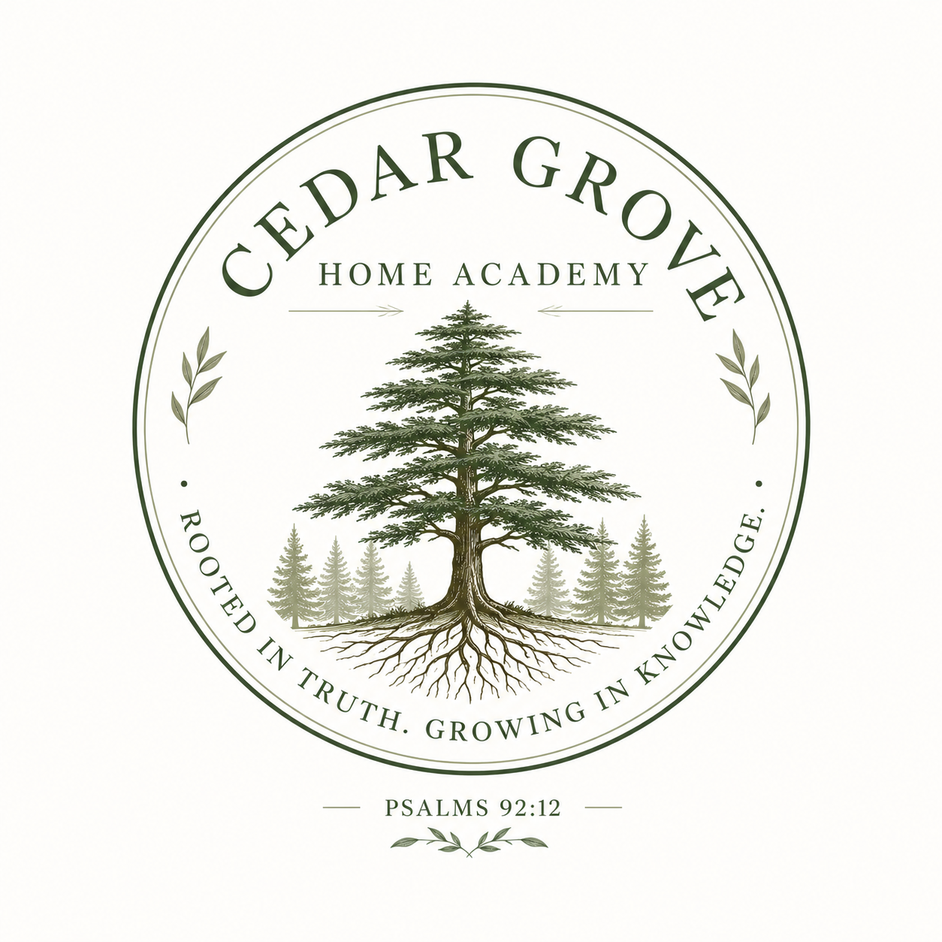 | CEDAR GROVE  H O M E A C A D E M Y
GRADE & COURSEWORK RECORD
Student Name: ________________________ | Grade Level: ________________________
School Attended: ________________________ | School Year: ________________________
Program/Curriculum (optional): ________________________ | Date of Record: ________________________

# | SUBJECT / COURSE | FINAL GRADE
1 | __________________________________________________________ | ___________
2 | __________________________________________________________ | ___________
3 | __________________________________________________________ | ___________
4 | __________________________________________________________ | ___________
5 | __________________________________________________________ | ___________
6 | __________________________________________________________ | ___________
7 | __________________________________________________________ | ___________
8 | __________________________________________________________ | ___________
9 | __________________________________________________________ | ___________
10 | __________________________________________________________ | ___________

____________________________________________________ | ____________________
Parent/Teacher/Administrator Signature | Date
ROOTED IN TRUTH. GROWING IN KNOWLEDGE.
PSALMS 92:12

